MACH4METAL

Metalworking machinery
Transito 21,
6909 DA BABBERICH
Netherlands
Tel. +31 (0)316 – 247123
indo@mach4metal.com

Account No: 66.52.13.883
IBAN : NL33 INGB 0665 2138 83
BIC : INGBNL2A

AMADA ARIES 222 Punching machine
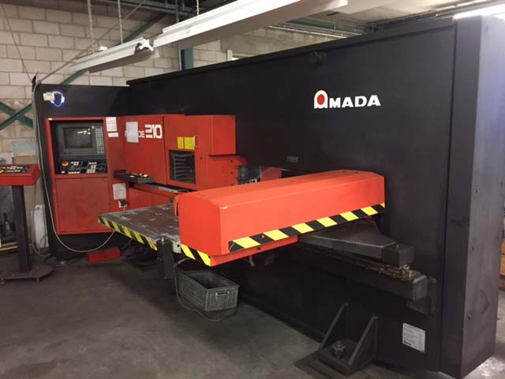

- Make : AMADA PROMECAM
- Type : ARIES 222
- YOP : 1990
- Serial :

- X Working area : 600
- X Override : 1.200
- Y Working area : 600
- Table load Kg : 25

- Punching force : 20 T
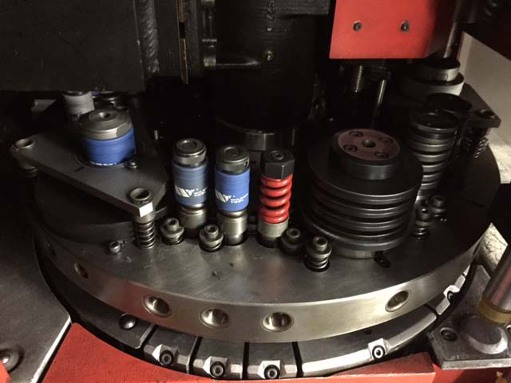
- Capacity thickness : 4.5 mm
- Minimum thickness : 0.8 mm
- Strokes / min : 200

- Turret 10 positions
- Max tool size Ø 88.9
- 8 X 1 ¼”
- 2 X 3”

- Control AMADAN-03P
- Large tooling package
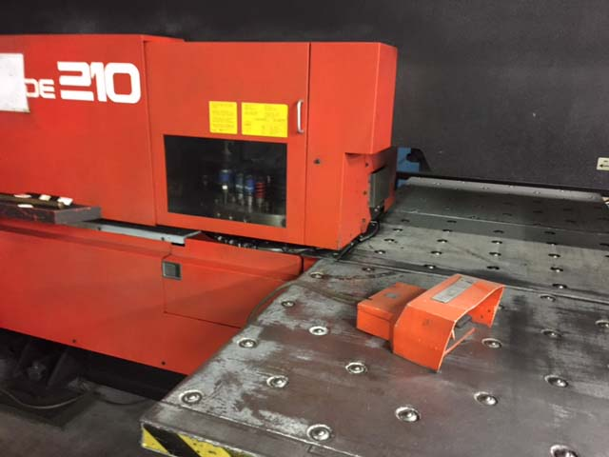

- Dimensions
- Length : 2.822
- Width : 1.657
- Height : 1.746
- Weight : 4.000

- Incl. safety guides
- Optional tooling package

Please Note: The above information has been obtained to the best of our ability and belief from, and from the manufacturers where possible. It is given in good faith, but its accuracy can not be guaranteed. Accordingly, it will not form a representation or constitute contractual terms. We advise you to check any vital details!

